**Pictures of Rapid Prototyped Parts**

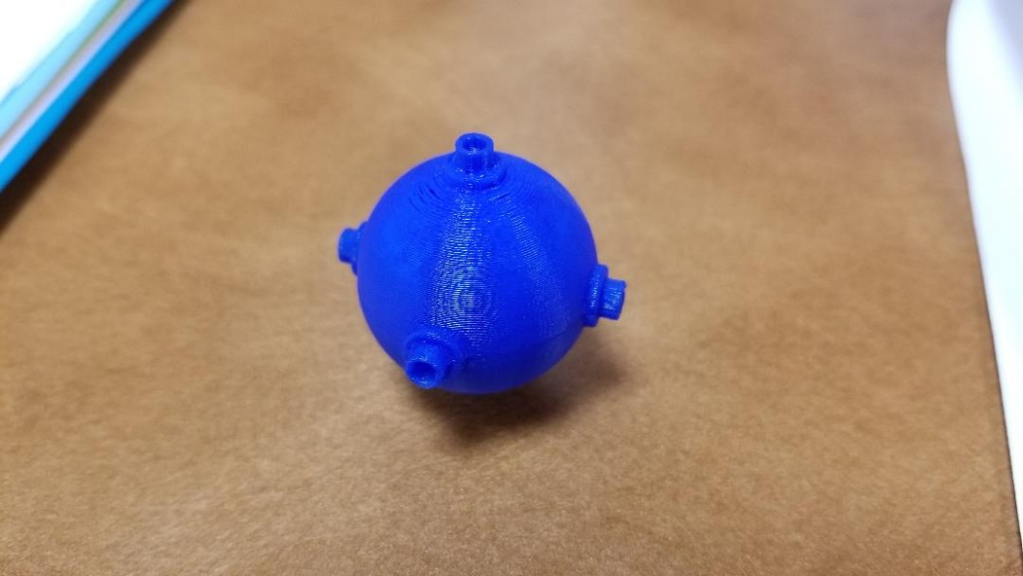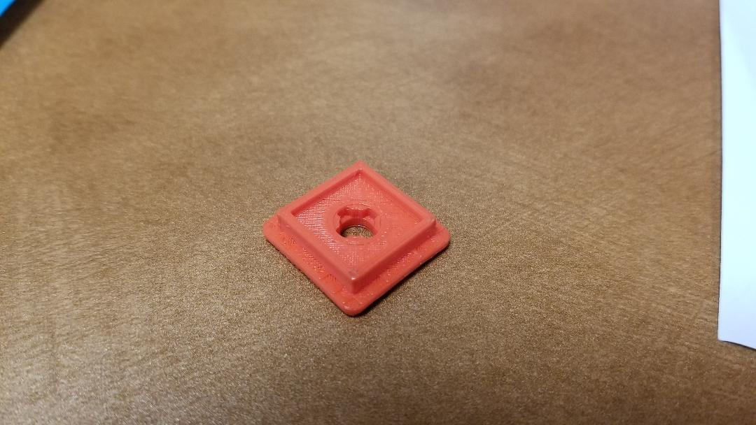

No. 1 Middle Piece Frame

No. 7 Center Piece Frame

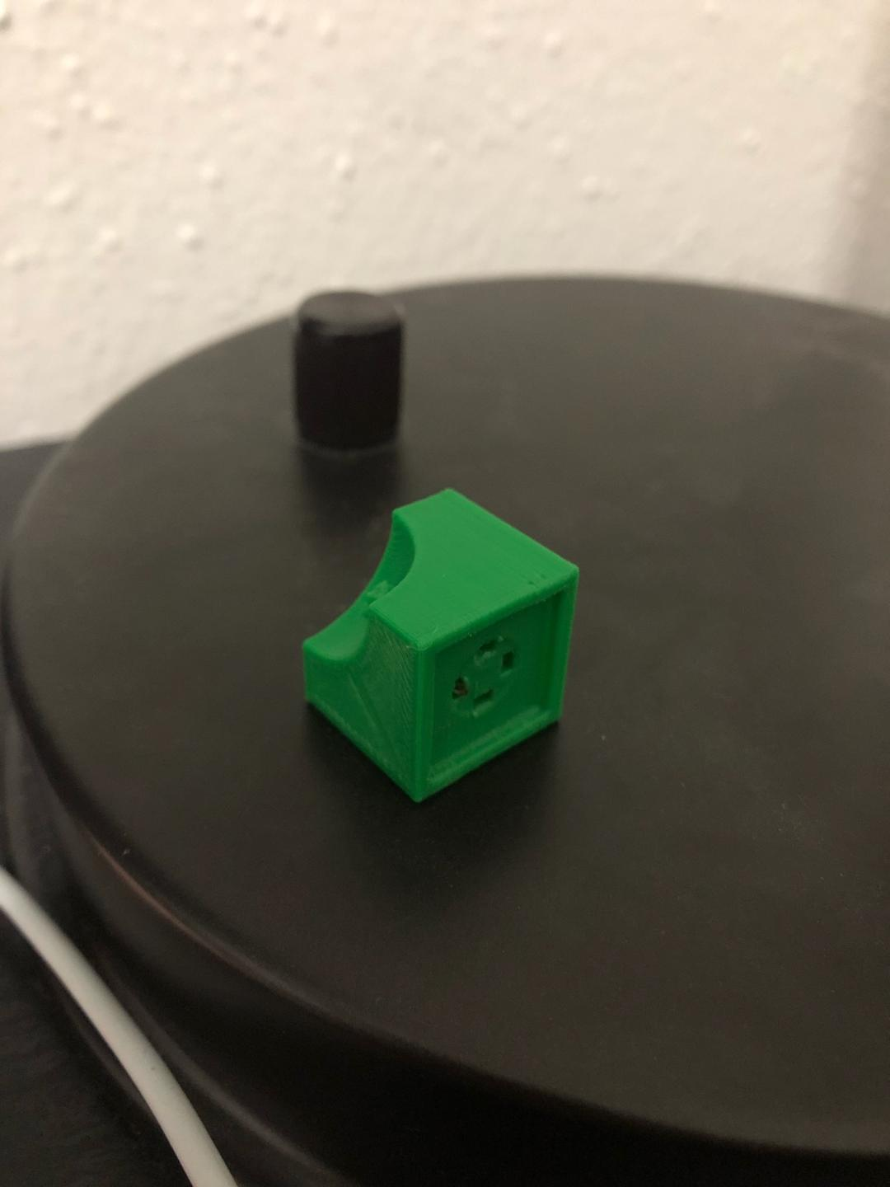

No. 3 Corner Piece Frame